**ABSTRACT**

**Gesture recognition** is a topic in computer science with the goal of interpreting human gestures via mathematical algorithms. Gestures can originate from any bodily motion or state but commonly originate from the face or hand. Gesture recognition enables humans to communicate with the machine and interact naturally without any mechanical devices. Using the concept of gesture recognition, it is possible to point a finger at the computer screen so that the cursor will move accordingly. This could make conventional input devices such as mouse, keyboards and even touch screens redundant.

In this project, we design a real-time human computer interaction system based on hand gesture. Hand gesture recognition system provides us a novel, natural, innovative user friendly way of communication with the computers. The whole system consists of three components: **Hand Detection, Gesture Recognition and Human-Computer Interaction (HCI)** based on recognition, and realizes the robust control of mouse and keyboard events with a higher accuracy of gesture recognition.

**CHAPTER 1**

**SYSTEM ANALYSIS**

**1.1 Overall Process :**

The system aims to design a vision-based hand gesture recognition system with a high correct detection rate along with a high-performance criterion, which can work in a real time HCI system which uses hand gestures as input for communication.

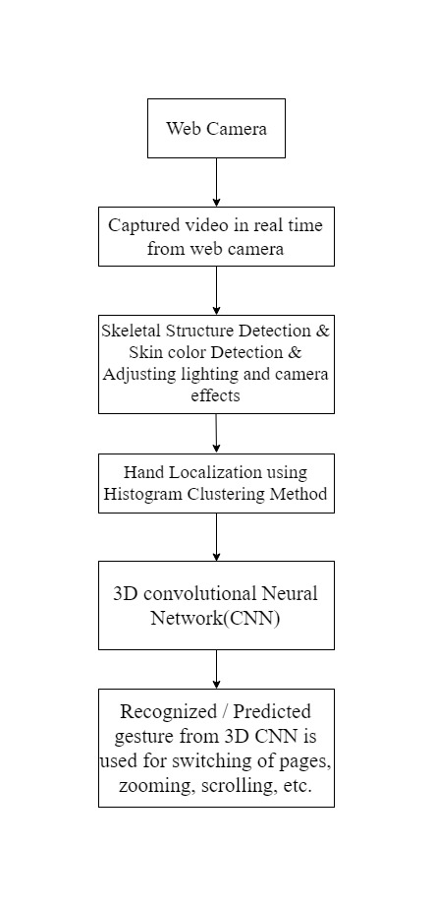

**Figure 1.1**

**1.2 Mapping Requirements :**

**Functional Requirements**

|  |  |  |  |
| --- | --- | --- | --- |
| SL.NO | Actors | Requirements | Module Mapping |
| 1. | Hand Detector | * An input image from the web camera is fetched at the rate of 20 frames per second. * The distance between the hand and web-camera must be within the range of 30-100cm. | * The TensorFlow object detector along with OpenCV detects the hand by creating a boundary around it. |
| 2. | Motion and Gesture Detector | * A processed matrix that consists of the movement of the detected hand. * Collection of frames of the desired gesture is captured and given as input to the 3D CNN. | * Recognition of the hand movement (left or right) and the gesture performed (zooming in and zooming out). * It interacts with the dataset for verification. |
| 3. | Communication and Interaction` | * The detected hand movement or the gesture from the trained CNN. | * Performs the required action on the PDF/PPT through PyAutoGUI or System Calls. |

**Non Functional Requirements**

|  |  |  |
| --- | --- | --- |
| SL.NO | Requirement | Description |
| 1. | Reliability and Safety | * The services provided by the system must be reliable. * The system must perform without any failures. |
| 2. | Accuracy | * The system must be able the detect only the hand in a given environment. * Must not detect any other object of the same colour. * The system must perform the correct action for the given gesture. |
| 3. | Efficiency | * Expecting an efficiency of 80% and above in all backgrounds. |
| 4. | Operability | * It works on any Operating System – Windows or Linux , that has a web-camera of 5MP or higher. |
| 5. | Usage | * Repeated usage will produce better results as it trains the 3D CNN for motion detection. |

**1.3 Functionalities of the Sub-System :**

The system is mainly divided into the following subsystems – Hand and Motion detection, Datasets and 3D Convolution Neural Network.

**Hand and Motion Detection :**

* The Web-camera captures the hand movement and provides it as input to OpenCV and TensorFlow Object detector.
* Edge detection and skin detection are performed to obtain the boundary of the hand.
* This is then sent to the 3D CNN.

**Dataset :**

* It is used for training the 3D CNN.
* Two types of datasets are being used – one for the hand detection and the other for the motion or gesture detection
* Hand detection uses EGO dataset.
* Motion or Gesture Recognition uses Jester dataset.

**3D CNN :**

* CNN’s are a class of deep learning neural networks used for analysing videos and images. It consists of several layers – input layer, hidden layers and output layer.
* It performs back propagation for better accuracy and efficiency.
* It performs training and verification of the recognised gestures and human computer interactions take place – turning of the pages, zooming in and zooming out.
* The interactions with the computer take place with the help of PyAutoGUI or System Calls.

**CHAPTER 2**

**SYSTEM DESIGN**

**2.1 Architectural Design :**

The following architecture will be used to perform the needed actions such as turning of pages, zooming in or zooming out.

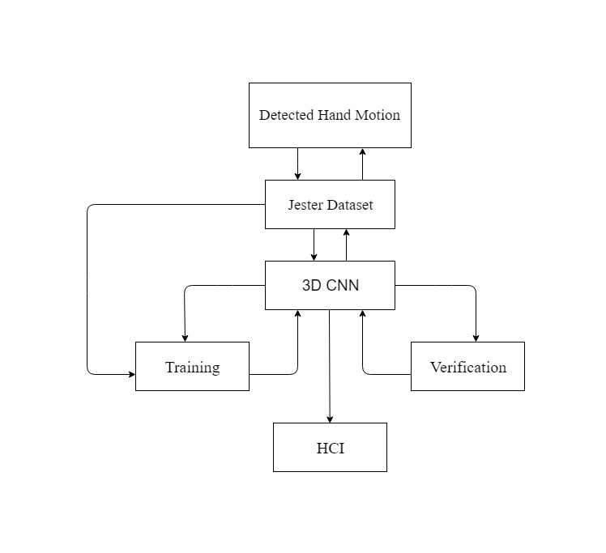

**Figure 2.1**

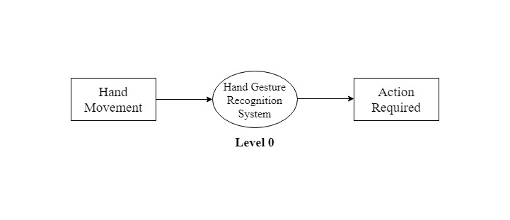

**Figure 2.2**

The above diagram, is a Level 0 Data Flow Diagram (DFD), where the input is a hand movement or a hand gesture that will be given to the Human Hand Recognition System. The output of this system will be the desired action that is required, such as turning of the pages,

zooming in or zooming out.

**2.2 Component Design :**

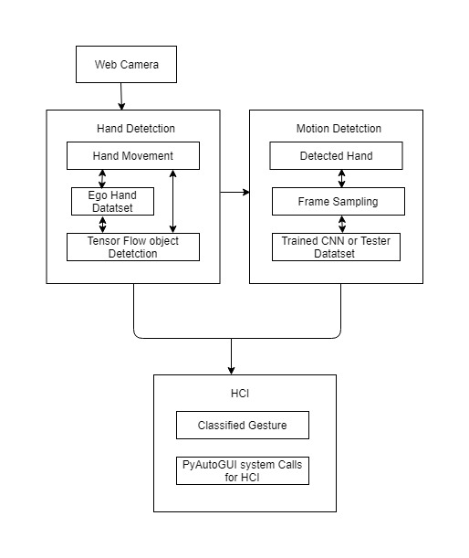

**Figure 2.3**

The system is divided into three main components :

* Hand detector
* Motion or gesture detector
* Human computer interaction

**Data Flow Diagrams (DFD’s)**

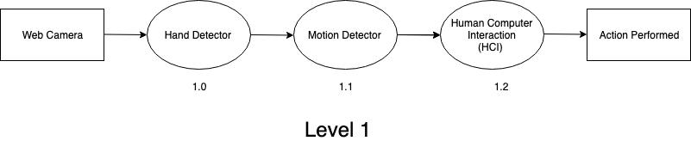

**Figure 2.4**

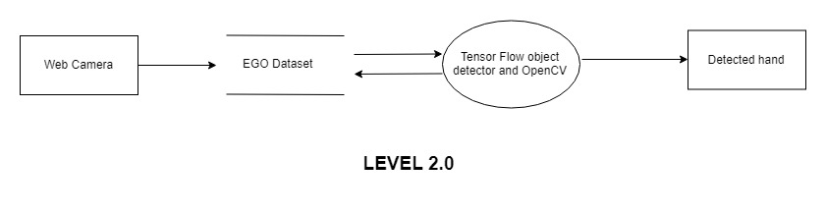

**Figure 2.5**

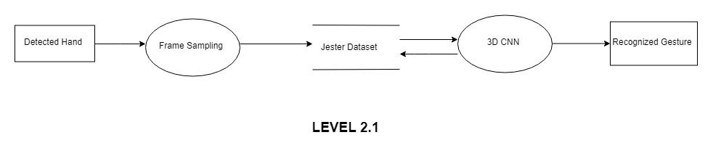

**Figure 2.6**

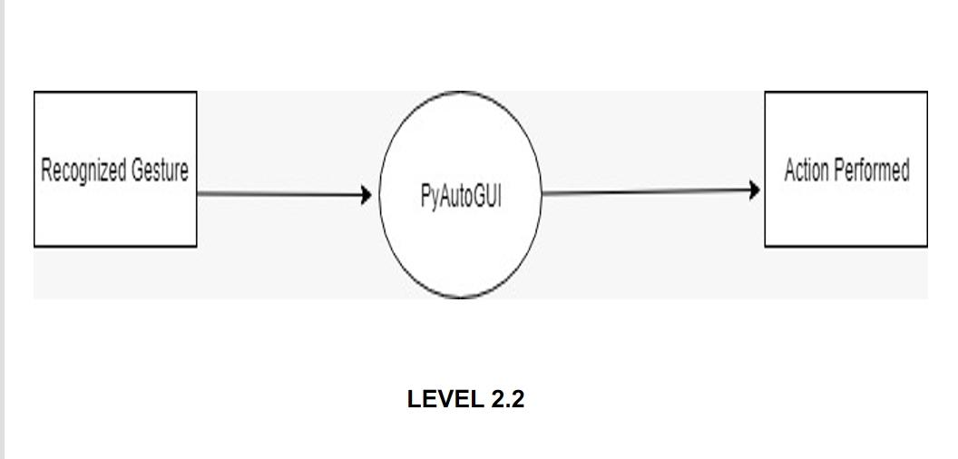

**Figure 2.7**

**2.3 Behavioural Design :**

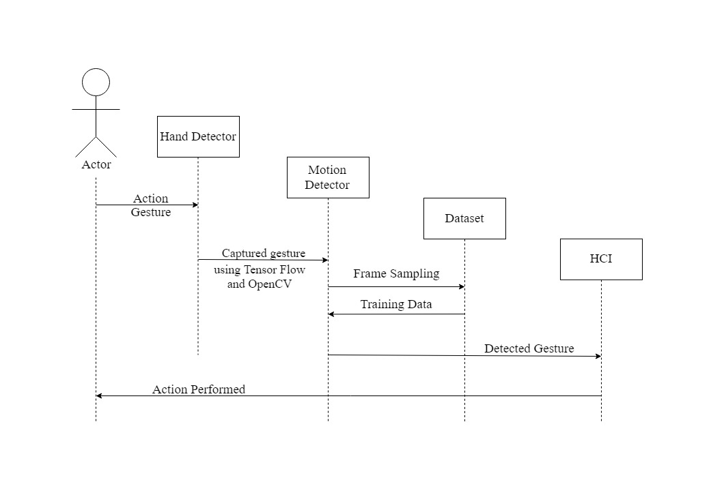

**Figure 2.8**

The above diagram shows the behavioural design of the system. The actor (the user) performs some action which will then be detected by the Hand detector using Tensor Flow object detector and OpenCV . The captured gesture is then sent to the Motion Detector which performs frame sampling and sends it to the dataset . The detected hand gesture is then sent to HCI which performs the required action as per the gesture, that is turning of pages, zooming in or zooming out.

**REFERENCES**

[1] Meenakshi Panwar, Pawan Singh Mehra**, Hand Gesture Recognition for Human Computer Interaction**, International Conference on Image Information Processing India (2011).

[2]Rafiqul Zaman Khan and Noor Adnan Ibraheem, **Comparitive Study Of Hand Gesture Recognition System**, AIRCC Digital Library – 2012.

[3]Arpita Ray Sarkar ,G. Sanyal , S. Majumder ,**Hand Gesture Recognition Systems: A Survey** ,International Journal of Computer Applications Volume 71– No.15, May 2013.

[4]Manjunath A E ,Vijaya Kumar B P , Rajesh H, **Comparative Study of Hand Gesture Recognition Algorithms**, International Journal of Research in Computer and Communication Technology, Vol 3, Issue 4, April- 2014.

[5] Dnyanada R Jadhav, L. M. R. J Lobo, **Navigation of PowerPoint Using Hand Gestures** ,International Journal of Science and Research (IJSR) 2015.

[6] Ruchi Manish Gurav, Premanand K. Kadbe, **Real time finger tracking and contour detection for gesture recognition using OpenCV**, IEEE Conference May 2015, Pune India.

[7] Pei Xu, Department of Electrical and Computer Engineering, University of Minnesota, **A Real-time Hand Gesture Recognition and Human-Computer Interaction System** ,Research Paper April 2017.

[8] P.Suganya, R.Sathya, K.Vijayalakshmi , **Detection and Recognition of Gestures To Control The System Applications by Neural Networks**, International Journal of Pure and Applied Mathematics 2018.